- Write the python program to solve 8-Puzzle problem
Aim:
To write a Python program to solve the 8-Puzzle Problem using the Breadth-First Search (BFS) algorithm.
Objectives
- To understand the 8-Puzzle problem.
- To represent the puzzle as a 3×3 matrix.
- To accept the initial and goal states from the user.
- To find the solution using the BFS algorithm.
- To display the sequence of moves from the initial state to the goal state.
Algorithm
- Start the program.
- Read the initial puzzle state from the user.
- Read the goal puzzle state from the user.
- Store the initial state in a queue.
- Mark the initial state as visited.
- Remove the first state from the queue.
- If it matches the goal state, display the solution and stop.
- Otherwise, move the blank space (0) in all possible directions.
- Add the new valid states to the queue if they are not visited.
- Repeat Steps 6–9 until the goal state is found.
- Stop the program.
Flowchart
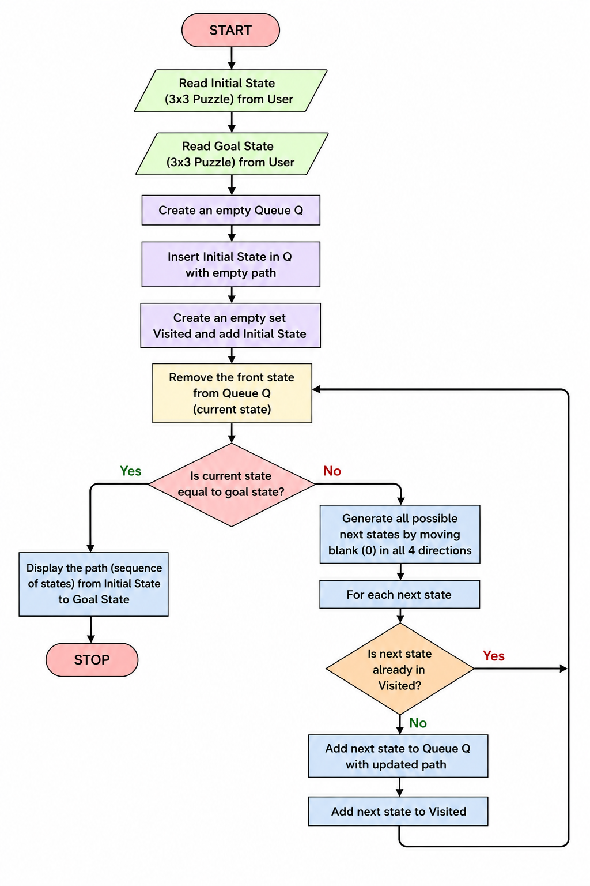
Code:
from collections import deque
def find_blank(state):
return state.index(0)
def get_neighbors(state):
neighbors = []
index = find_blank(state)
moves = {
0: [1,3],
1: [0,2,4],
2: [1,5],
3: [0,4,6],
4: [1,3,5,7],
5: [2,4,8],
6: [3,7],
7: [4,6,8],
8: [5,7]
}
for move in moves[index]:
new_state = state[:]
new_state[index], new_state[move] = new_state[move], new_state[index]
neighbors.append(new_state)
return neighbors
def bfs(start, goal):
queue = deque()
queue.append((start, []))
visited = []
while queue:
current, path = queue.popleft()
if current == goal:
return path + [current]
if current not in visited:
visited.append(current)
for neighbor in get_neighbors(current):
if neighbor not in visited:
queue.append((neighbor, path + [current]))
return None
def print_state(state):
for i in range(0,9,3):
print(state[i:i+3])
print()
print("Enter Initial State (Use 0 for Blank):")
start = list(map(int, input().split()))
print("Enter Goal State (Use 0 for Blank):")
goal = list(map(int, input().split()))
solution = bfs(start, goal)
if solution:
print("\nSolution Found!\n")
step = 0
for state in solution:
print("Step", step)
print_state(state)
step += 1
else:
print("No Solution Found.")
Output

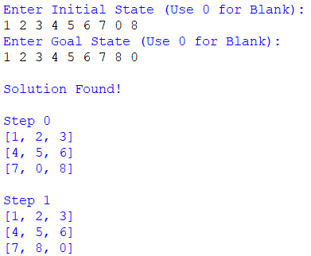

Result
Thus, the 8-Puzzle problem was successfully solved using the Breadth-First Search (BFS) algorithm. The program found the shortest sequence of moves from the initial state to the goal state and displayed each step of the solution.

